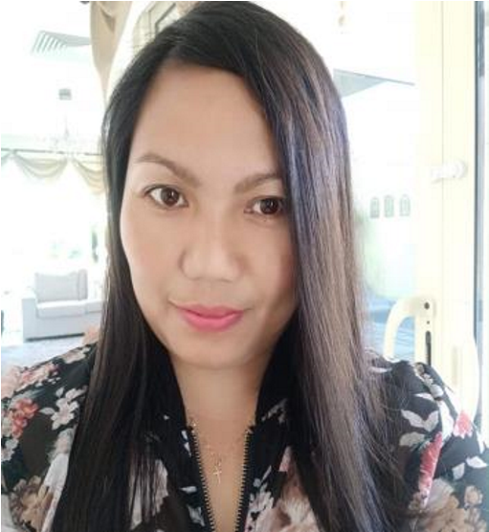

Melanie Gaza Ablaneda

Khalifa City A sector 7 Villa 20

Abu Dhabi UAE

E: gazamelanie75@gmail.com

Tel.# : +971 561 960 692

# Professional Summary

Professional domestic worker with more than 12 years of experience, serving emirati (local) family in residential settings. Detail-oriented with excellent ability to manage time and keep schedules organized . Flexible individual who can implement changes at short notice. Friendly, personable and always professional.

# Skills

* Highly organized with an ability to maintain schedules, grocery lists, to-do lists, and other home management necessities with precise accuracy.
* Physically strong enough to do heavy lifting and work on my feet for multiple hours per day as sometimes necessary for cleaning and organizational purposes.
* Flexible individual who understands that schedules and duties sometimes change unexpectedly and can quickly make the necessary adjustments to continue to fulfill them.
* Excellent command of the English language with a strong ability to remember and follow directions after hearing them only once.

Housekeeper June 2011 – Present

* Performed daily cleaning tasks such as doing dishes, dusting, vacuuming, and straightening up small messes throughout the home.
* Performed larger cleaning tasks on a regular schedule that included doing laundry, washing windows, organizing storage spaces, and waxing floors.
* Performed cooking meals, running errands, and ensuring any guests are taken care of and happy with their stay.

Nanny August 2015 - 2021

* Ensured the safety of three small children at all times, including during bedtime, at home during the day, and while on outings.
* Assisted the three school-age children with reading, writing, math, and science tutoring, ensuring all homework was completed and ready to be turned in.
* Maintained schedules for extracurricular activities, transported the children to activities, and ensured they had the equipment necessary to participate.

# Education

Highschool Bachelor of Science in Computer Science

Mabini Colleges Inc. Mabini Colleges Inc.

Daet, Camarines Norte Daet, Camarines Norte

1989-1993 1993-199

Reference:

THURAYA AL MASKARI +971 50 681 1726

SAFIYA AL MASKARI +971 50 429 9693